A Simple Shopping Mobile App- Product Requirement Document

|  |  |
| --- | --- |
| **Target release** | January 23, 2025 |
| **Epic** |  |
| **Document status** | **DRAFT** |
| **Document owner** | @Nnabuife Blessinh |
| **Designer** | @Testify ltd |
| **Tech lead** | @Titilayo Nubi |
| **Technical writers** | Samuel  Oyinkan Chioma |
| **QA** | Muhammed Sule |
| **Product Name** | Shop with ease  **Version:** 1.0  **Date:** Jan 23, 2025 |
| **Stakeholders** | Public customers  Mobile app development team Customer support and service team  Security and compliance team |

## Introduction

 **Purpose:** The simple mobile app aims to provide customers with a convenient and secure platform for managing their shopping needs through their mobile devices.

 **Target Audience:** customers who want quick and easy access to different fashion and clothing services.

 **Scope:** The app will include features for adding to cart, payment with cards or bank transfers, delivery details, return policy and customer support.

## Product Overview

 **Vision Statement:** To make shopping easy and stress-free by shopping at the comfort of your home and having it delivered to your doorstep.

## Objective:

Enable users to have access to varieties of products in one shop .  Facilitate secure fund transfers and payments with cards.

* Provide timely and personalized notifications on goods been delivered
* .  Offer a straightforward and intuitive user interface.

 Ensure compliance with shopping policies and standards.

## User Personas:

**Persona 1: Frequent User**

 *Demographics:* Age 18-65, tech-savvy.

 *Needs:* Quick and easy shopping experience.

... (Additional user personas)

# Success metrics

|  |  |
| --- | --- |
| **Goal** | **Metric** |
| Simplify User experience | Customer satisfaction score increases from 3 to 5 |
| **Downloads:**  The total number of times the app has been downloaded. | 1000 downloads in one month |
| **Active Users:**  The number of users who actively use the app within a specific time period (daily, weekly, monthly). | 500 active monthly users |

 Assumptions

Users have smartphones with internet connectivity.

**Risks:** Potential delays due to unforeseen technical challenges.

# Milestones

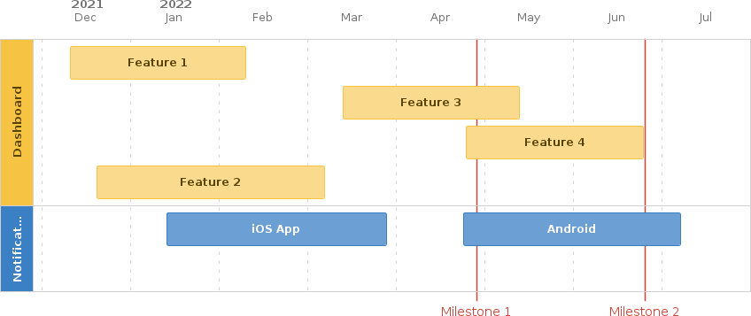

 Requirements

|  |  |  |  |  |
| --- | --- | --- | --- | --- |
| **Requirement** | **User Story** | **Importan ce** | **Jira Issue** | **Notes** |
| **Home page** | *Description:* Users can view their options and different categories. | **HIGH** | MA-110 |  |

|  |  |  |  |  |
| --- | --- | --- | --- | --- |
|  | *Acceptance Criteria:* Real-time updates with available products. |  |  |  |
| **Add to Cart** | *Description:* Users can select multiple items .  *Acceptance Criteria:* Multi-factor authentication, seamless selection of products. | **HIGH** | MA-111 |  |
| **Payment Methods**  **Return policy**  **In-App Customer Support** | .  *Description:* Users can pay bills for utilities, services, and credit cards directly through the app.  *Acceptance Criteria:* payments. Can be made with cards, Transfer, and pay on delivery.  *Description:* Users can return product upon delivery if dissatisfied.  *Acceptance Criteria:* All packaging and labels must be intact..  *Description:* Users can initiate a chat with customer support for queries and assistance.  *Acceptance Criteria:* Instant response, secure communication. | **HIGH** | MA-112  MA-113  MA-114 |  |

**Non-Functional Requirements**

 **Performance:** App should load within 3 seconds; support a minimum of 10,000 simultaneous users.

 **Security:** Encryption of sensitive data, compliance with banking security standards.

 **Usability:** Intuitive design, accessibility features for all users.

 **Compatibility:** Support for iOS and Android platforms.

## Technical Specifications

 **Technology Stack:**

 React Native for cross-platform development.

 Backend using Node.js and MongoDB for scalability.  Integration with banking APIs for transactions.

## Constraints

 **Budgetary Constraints:** Allocated budget of $X for development.

 **Time Constraints:** Launch planned within 6 months from project initiation.

# User interaction and design

https/figma.com/moble app..

 Open Questions

|  |  |  |
| --- | --- | --- |
| **Question** | **Answer** | **Date Answered** |
|  |  |  |

# Out of Scope

IOS app and We application

**Approval**

## Signatures:

 [Project Manager]  [Product Owner]

 [Stakeholder Representatives]